ACtivity 2

HAND SPANS – measuring variability

# DIRECTIONS

Have one group member upload this docx file to your Google Drive and share it with your groupmates and your instructor. Name your document “**GroupX_Activity2”** (where X is your group number). Work together to type up your responses to each question. Download your document as a PDF and submit this to Canvas individually.

# CREATING A RULER

We will begin this activity by collecting data on how long your hand span is. To measure this, use the online ruler linked below:

<https://www.ginifab.com/feeds/cm_to_inch/actual_size_ruler.html>

You can use a credit card or your i-Card to calibrate the ruler on your screen to ensure it is accurate. To do this, scroll down and select “standard credit card” as the ruler adjuster as shown below:

Once you do this, a green bar will appear on the top ruler to show the width of a typical card. Put your credit card or i-Card on the screen, and then click/drag your ruler to the left or right until the green bar matches the width of your card. Now your screen should work as an accurate ruler!

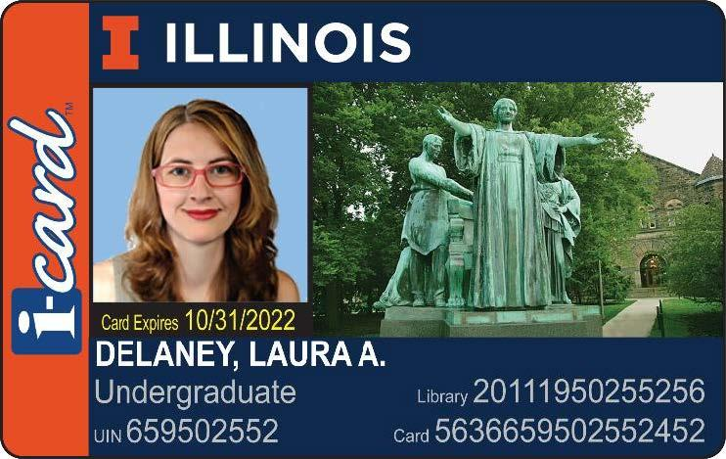

# COLLECTING DATA

1. Spread your hand on a ruler as far out as you can and measure your hand span (the distance from the tip of your thumb to the tip of your little finger when you spread your fingers) to the nearest tenth of a centimeter. **Record everyone’s measurements in the blanks below and then enter each person’s measurement into the Google Form linked below:**

<https://forms.gle/dfzLJwsoSQmG52GbA>

____’s Hand-span ___________________

____’s Hand-span ___________________

____’s Hand-span ___________________

1. **Now, you will combine with other groups temporarily just to collect and record data for your hand spans**. **Combine enough groups together so you have 6-8 people.** In a new TinkerPlots document, make a case table with two attributes: *Name* and *HandSpan*. Enter the names and measurements for the people you worked with collecting handspans. Copy and paste your case table containing your measurements here.

# INVESTIGATING THE DATA

1. Make a dot plot of the hand-span measurements. Copy and paste your dot plot here.
2. Plot the mean hand-span on your dot plot. Show the mean on your plot or paste a new plot with the mean line shown.

**Mean Hand-span for your group’s measurements =**

1. Give two sources of variability in your measurements. That is, give two reasons why the measurements are not all the same.

1. How far was each group member’s hand-span from the mean of your group's data set? Was it higher or lower than the mean? Whose hand-span varied the most from the mean?

Our goal with this data is to understand the variability in our hand span measurements from these small groups and to come up with a way to summarize the variability in our data set **numerically**. That is, we want to summarize the variability with a single numerical measure that is larger when the data are more variable, and lower when the data are less variable.

To begin understanding how to quantify this, we will investigate how far each observation is from the mean. To show these differences from the mean in TinkerPlots, add a new column to your case table that shows the difference of each data value from the mean. Set this up with the formula editor as shown below:

The mean() function can be found under **Functions -> Statistical -> One Attribute**, or you can type the function in directly.

1. Make a dot plot of these differences. Copy and paste your plot below.
2. What is the mean of these differences? What does this value mean? Explain. Plot this value on your dot plot of the deviations and copy and paste the plot below.

1. Try changing a couple of the hand-span values in your data set. Experiment! Add a few new values to the data set (try outliers or values close to the mean too). Each time you change or add new values to the hand-span data, what do you notice about the deviation data, specifically about the mean of the deviations? Explain!

1. Is the mean of these differences a good measure of variability, that is, how spread out the values are? Explain.

1. Using the idea of the difference from the mean, think of two different measures that give a “typical” distance from the mean that fix the problem we encountered with just taking the difference between the observation and the mean. Write down your measures here!

1. Open the TinkerPlots document *ClassHandSpans.* This contains all the hand-span data from the entire class.
   1. Make a dot plot of the classroom data set, copy and paste the graph below. Be sure to show the mean value on the plot.
   2. Compute the difference between each person’s hand-span and mean hand-span. Then make a plot of these differences and paste it below.
   3. Use one measure for computing the *typical distance from the mean* and compute it for the class hand-span data set. What is the typical distance value you found?
   4. What makes a typical deviation a good measure of variability? Discuss.

A common measure of variability used in statistics is known as the **standard deviation**. This value is interpreted in a similar manner to the typical deviation we calculated previously, but is more commonly used in statistical practice. We can calculate the standard deviation in TinkerPlots too!

Create another new column in your data table, and give it any sensible name like “Standard Deviation” or “SD” or something similar. Open up the “edit formula” editor on this new column. We want to create a formula like the one shown below:

The “stdDev()” function can be found under **Functions -> Statistical -> One Attribute**. Be careful to select the right name, there are many similarly named functions here!

1. What is the standard deviation for the classroom hand span data? How do your values for the standard deviation and the typical deviation compare to each other?
2. Based on how we built our measures of variation in this activity, write a sentence to interpret your standard deviation value for the classroom data set.